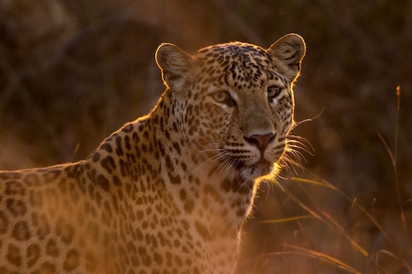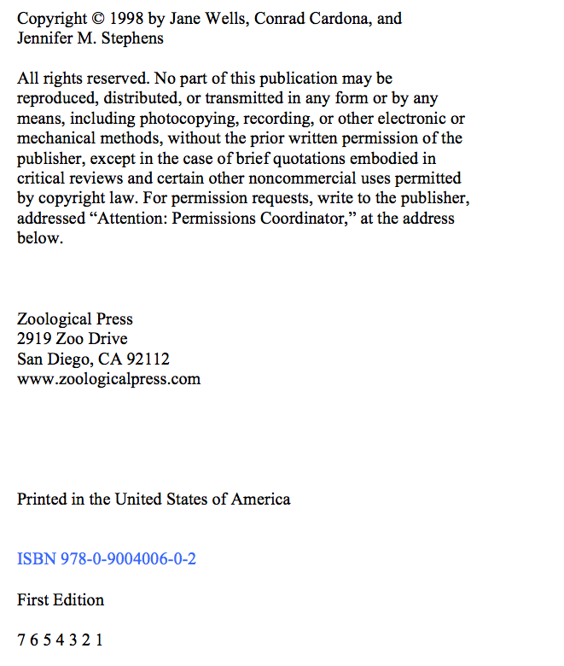

A Field Guide to

Big Cats

Jane Wells,

Conrad Cardona,

Jennifer M. Stephens

Zoological Press

Scroll down to view the second source



Nature Photos

www.naturephoto.ca/lion

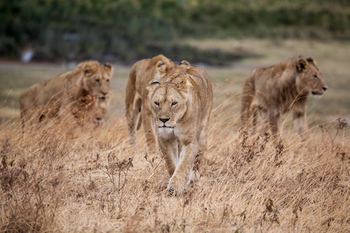

Lions on the Savannah

Kris Burlingame, 2001

X